**Walmart Weekly Sales**

Student’s Name

Institutional Affiliation

Course Number and Name

Instructor Name

Due Date

**Introduction**

The Walmart Weekly Sales Dashboard is a potent tool meticulously crafted to delve into the intricate web of sales dynamics, unveiling trends, patterns, and vital data-driven insights. This report embarks on an exploration of the pivotal visualizations presented within the dashboard, including a comprehensive line graph illustrating the Sum of weekly sales over an extended period from 2010 to 2012, an enlightening bar graph vividly portraying the Sum of weekly sales categorized by store, another insightful bar graph depicting the relationship between store size and type, and an analytical examination of the Consumer Price Index (CPI) and unemployment rate as influenced by the time factor and the presence of holidays. Lastly, we scrutinize a graph delving into the essence of department-specific weekly sales. This report aspires to extract invaluable insights from the tapestry of data available for 45 stores of Walmart, ultimately endeavoring to provide actionable recommendations for enhancing Walmart's weekly sales performance.

**Problem Statement**

The Walmart Weekly Sales Dashboard emerges as a potent tool, yet the underlying complexities of sales trends, store performance, economic influences, and departmental dynamics warrant a comprehensive investigation. The challenge lies in uncovering actionable insights and recommendations that can empower Walmart to optimize its weekly sales performance.

One of the key issues addressed by this dashboard is the identification of sales patterns over time and the ability to use this knowledge for better inventory management and marketing tactics. Furthermore, understanding the performance of various store sizes and kinds is critical since it can drive business plans and resource allocation. Understanding the influence of holidays on sales, as well as the relationship between economic indicators such as CPI and unemployment rates, and sales trends, is critical for improving Walmart's business operations. Therefore, the overarching problem is deciphering the multifaceted elements that influence weekly sales at Walmart and providing concrete recommendations to enhance sales performance and customer satisfaction.

**Methods**

Walmart's weekly sales dataset was obtained from Kaggle.com, where three CSV files were downloaded. The first CSV file is known as 'features' and comprises variables such as store, date, temperature, fuel price, Markdown 1, 2, 3, 4, and 5, CPI, unemployment, and IsHoliday. The second CSV file is 'store' and contains column headers such as store, type, and size. The third CSV file is known as 'train' and has variables such as the store, dept, date, weekly sales, and IsHoliday.

The CSV files were then loaded to Power BI for visualization. First, the three files/tables were transformed using Power Query Editor. All the unnecessary columns were removed using the "remove column" tab at the top ribbon. Data types were also checked and changed where necessary. The "custom column" in the "add column" tab also added two new columns to the 'features' table. The first new column added was "Months". It was extracted from the "date" column using the appropriate formula. The second new column added was "Season". It was generated from the "Months" column using the appropriate formula. Additionally, data cleaning was done to remove the empty values in all tables.

A relationship was established between the three tables where the "store" column, the common column, was used to link all three tables. Afterward, visualizations were created on the report view section, and a dashboard was generated from those visuals. Dashboard was then used to generate crucial insights that offered solutions to the stated problems.

**Weekly Sales Trends**

One of the cornerstone elements of the Walmart Weekly Sales Dashboard is the sales trends visualization. This line chart provides a historical perspective on weekly sales figures from 2010 to 2012. Evaluating this chart, an individual can gather numerous major trends and observations that shed light on Walmart's weekly sales performance. First and foremost, the graphic clearly shows that it spans three years, from 2010 to 2012. In 2010, cumulative weekly sales exceeded 2.3 billion dollars, indicating a strong sales performance. That year was marked by economic recovery following the global financial crisis, and various factors, including Thanksgiving and Christmas celebrations, contributed to the heightened sales levels.

In 2011, the line chart revealed a substantial increase in weekly sales, totaling approximately 2.45 billion dollars. This surge indicates a continuation of the positive sales trajectory and a substantial growth in Walmart's sales revenue. Effective marketing campaigns, a broader product range, and enhanced customer engagement strategies likely played a role in this impressive performance.

However, a contrasting pattern emerges as we shift our focus to 2012. The line chart illustrates a notable drop in weekly sales, totaling around 2 billion dollars. This reduction occurred throughout 2011 and 2012 and can be attributable to several things. The economic recession throughout this period significantly affected consumer purchasing habits and lowered retail sales in general. Additionally, it is worth noting that some customers diversified their shopping destinations, turning to alternative stores such as drugstores and dollar stores, seeking potentially more cost-effective options (Clifford, 2011).

**Store Performance**

A pivotal aspect of the Walmart Weekly Sales Dashboard revolves around understanding the performance of the diverse stores that constitute the Walmart chain. This insight into individual store performance is vital for optimizing resource allocation, devising targeted marketing strategies, and tailoring operational decisions to suit the unique characteristics of each store type. The dashboard presents a compelling bar chart that offers an in-depth view of sales categorized by store type. This chart's meticulous analysis shows that Walmart's 45 stores have been thoughtfully categorized into Type A, Type B, and Type C.

Type A stores stand out as the largest among the three categories. These behemoths in the Walmart chain are characterized by their expansive sizes, which accommodate various products and departments. Unsurprisingly, their sheer scale is reflected in the substantial weekly sales figures they command. These stores consistently secure the top position in terms of weekly sales, reaffirming the correlation between store size and sales revenue. Their capacity to offer a wide range of products and services attracts an appealing consumer base, contributing to their dominant market position.

Type B stores fall in the middle of the range, with significant sizes and outstanding weekly sales figures. While not as numerous as Type A, they have a significant presence on the sales ladder. Their success, which ranks second in size and sales, demonstrates their importance inside the Walmart organization. These stores frequently serve a more localized consumer base and play an important role in serving certain areas.

While smaller than their Type A and Type B counterparts, Type C stores are essential in the Walmart ecosystem. Although they exhibit more modest weekly sales figures, their presence is crucial for extending Walmart's reach to areas with lower population density or specific demographic characteristics. These stores cater to niche markets and fulfill customers' retail needs in less densely populated regions.

**Impact of Unemployment and CPI on Weekly Sales**

Within the Walmart Weekly Sales Dashboard, a compelling insight emerges from examining two bar graphs, shedding light on the intricate relationship between unemployment rates, the Consumer Price Index (CPI), and weekly sales. These economic indicators are pivotal in influencing consumers' purchasing power and spending patterns, consequently profoundly impacting Walmart's weekly sales figures.

In 2011, the dashboard revealed a distinctive trend characterized by lower rates of unemployment and a more moderate CPI. This alignment of economic factors can be credited as a catalyst for the heightened weekly sales observed during that period. Lower unemployment rates signify a larger portion of the population engaged in the workforce, thereby enjoying a steady income stream. This, in turn, translates into increased purchasing power, as gainfully employed individuals are more inclined to spend on retail goods and services. The coaction between reduced unemployment and a controlled CPI implies that customers' expenditure retains its value, enabling them to acquire goods and services at a reasonable cost. Consequently, Walmart witnessed an upswing in its weekly sales, fueled by the substantial spending capacity of the populace.

Conversely, in the subsequent year, 2012, the economic landscape displayed a contrasting picture. High CPI levels, accompanied by elevated unemployment rates, marked this period. These conditions collectively contributed to the discernible decline in Walmart's weekly sales. High CPI values indicate inflationary pressures, eroding the currency's value over time. Customers' purchasing power falls in such an environment as product and service expenses grow. This translates to a more cautious approach to purchasing, with people gravitating toward critical items and reducing discretionary spending. Furthermore, the increase in unemployment means a greater segment of the population dealing with financial insecurity, thus limiting their inclination and capacity to engage in retail therapy.

**Impact of Holiday on Weekly Sales**

Based on the Walmart Weekly Sales Dashboard, both holiday and non-holiday contribute proportionately to weekly sales, accounting for around 50% of total holiday sales. This balance implies that, unlike economic indexes such as the Consumer Price Index and unemployment rates, holidays have little impact on Walmart's sales success. Walmart's sales engine looks resilient, matching consumer needs year after year. While holidays provide unique possibilities for marketing and engagement, their impact on revenue is more consistent. Understanding this relationship enables Walmart to successfully change strategy, guaranteeing consistent sales performance irrespective of the holiday calendar.

**Conclusion**

In summary, the Walmart Weekly Sales Dashboard presented a comprehensive perspective of Walmart's sales dynamics, providing insights into weekly sales trends, store performance, economic effects, and the impact of holidays. Understanding these dynamics is critical for making sound decisions to improve weekly sales success and consumer satisfaction.

Weekly sales trends from 2010 to 2012 revealed a stunning upward trend followed by a downward trend. Economic recovery, successful marketing efforts, and holidays greatly impacted these patterns. Walmart should utilize agile tactics that respond to economic variations to capitalize on growth and prevent cuts.

Store Performance Analysis classified stores into three types: A, B, and C, emphasizing the relationship between store size and sales revenue. Walmart must keep investing in Type A and B stores while recognizing the value of Type C stores in niche markets to maximize performance.

Unemployment and CPI's impact on weekly sales emphasized the importance of consumer purchasing power. Leveraging insights from 2011, Walmart should focus on strategies that align with reduced unemployment and controlled CPI, such as targeted promotions and product diversification. Conversely, cost-effective pricing and essential product offerings become critical during economic challenges.

Regarding the Impact of Holidays, while holidays offer unique opportunities for engagement, Walmart's sales resilience during non-holiday periods showcases the importance of consistent strategies throughout the year.

**Recommendations**

1. Implement data-driven marketing campaigns to target specific customer segments during economic fluctuations.
2. Optimize inventory management strategies to meet demand variations during peak and non-holiday periods.
3. Continue investing in Type A and B stores for sustained sales growth while recognizing the significance of Type C stores in niche markets.
4. Monitor economic indicators closely to adjust pricing and promotions according to consumer purchasing power.
5. Maintain a consistent approach to customer engagement and product offerings throughout the year to sustain stable sales performance.

**Reference**

Clifford, S. (2011, February 22). U.S. Sales At Wal-Mart Show Decline. *The New York Times*. https://www.nytimes.com/2011/02/23/business/economy/23shop.html

**Appendices**

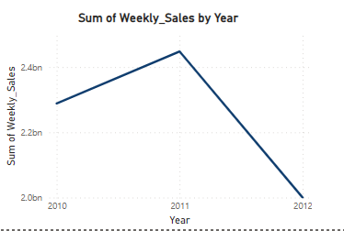

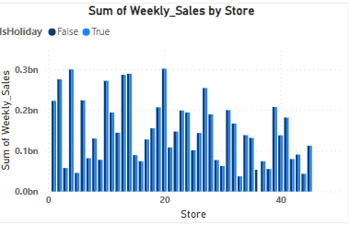

**Power Query Editor Activities**

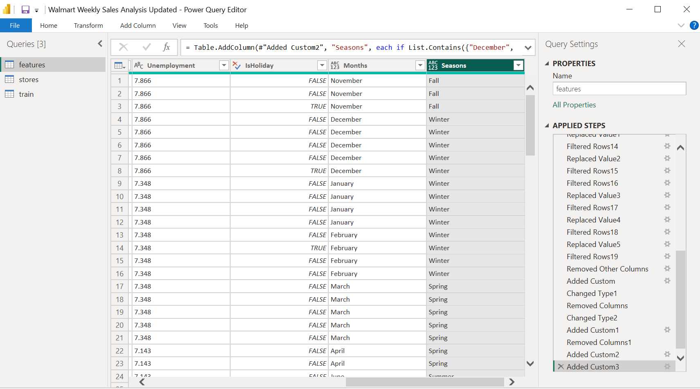

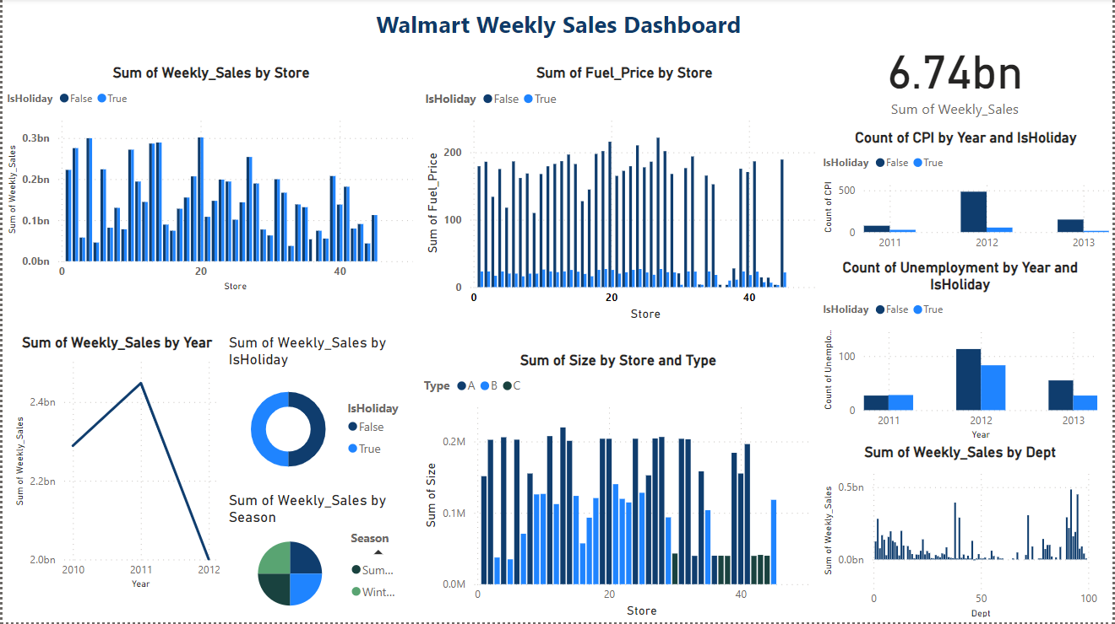

**Links**

Source: <https://www.kaggle.com/datasets/aslanahmedov/walmart-sales-forecast>

Dashboard Link: <https://app.powerbi.com/groups/me/reports/269597cd-00eb-4b11-8df1-a4d1748f68dc/ReportSection?experience=power-bi>